Lab 09.1: Working with Inheritance

Objective

This lab will provide some practice in using inheritance. You will also experiment with overriding methods and using information from an inherited class.

Overview

In this lab you will:
- Create a new class that extends an existing class
- Implement methods using overriding
- Add new functionality
- Create objects and test your new code

Step by Step Instructions

Exercise 1: Using the extends keyword

- Create a new class named Cube that extends Box and place it in the com.lq.exercises package in the ClassExercises project.

- A Cube is like a Box however all three dimensions of a Cube must be the same. We simulated this in our Box class by providing a constructor that would set all 3 sides to the same value. We will formalize this here. We don’t really need any new attributes since we inherit everything we need from Box.

- The first thing we need to do is define a constructor for Cube. Since a Cube must have all 3 sides set to the same value, our constructor only needs one parameter. We do not need to set any data in the Cube class so all we need is a call to our super class constructor [Hint: Use the super keyword as the first line in the Cube constructor].

- Cube inherits all the public methods from Box. However, if we set the length of a Cube to a new value, we also want to guarantee that the height and width are updated as well. Override each of the following methods in the Cube class to guarantee this functionality. (Remember, an overridden method must have the exact same signature as the base class method it is overriding).

  - setLength()
  - setWidth()
  - setHeight()

Here is what it might look like for one of the methods. Note that the author chose to only change the value if a different one has been passed in.

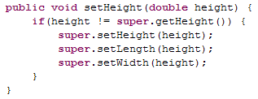

Exercise 2: Adding Functionality to Cube

- Add two new methods to get and set the sides of the Cube to a value. These methods work in a similar manner to the Box methods but will only be available to cubes.

  - Create a setSide() method that takes one parameter of type double and returns a void. Ensure that the sides are set to a valid value (>0).
  - Create a getSide() method that takes no parameters and returns a double.

Exercise 3: Try out the Cube class

- Create a new class named CubeDriver in the com.lq.exercises package. Ensure that this class has a main() method defined.

- In the main method of CubeTest, create two Cube objects using the keyword new.
  - A cube named cube1 with all sides set to 5
  - A cube named cube2 with all sides set to 8

- Using the get methods, print out the value for each attribute of both cubes. Ensure that the attributes were set correctly by the Cube constructor. Execute the main() method for CubeDriver. The output should be similar to the following. If there are any errors in your Cube code at this point, correct them and re-run the test.

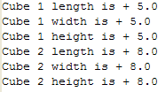

- Ensure that your set methods work correctly. Call the setLength() method for Cube cube1 and change the length to 20. Use the inherited printBox() method to ensure that all sides were set correctly. Do the same test again calling the setSide() method with a value of 40. Your output should look as follows:

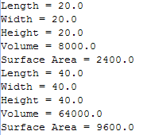

- Using the setWidth() method, change the width of Cube cube2 to -5. Did you receive the appropriate error message? Execute the printBox() method again and ensure that the value was not changed. Your output should look as follows:

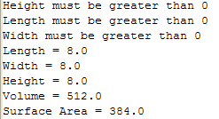

Challenge Exercises:

Refactor your code to eliminate duplicate logic.

Experiment with different algorithms so that you don’t receive 3 error messages when you try and change the size of a cube to an invalid value. There are many ways of handling this situation. Explore different techniques.

Is there any way that inheritance might be put to good use in your Calculator classes? Write a driver to exercise your Calculator classes.

